Technical Report - Group P3-G01 Project 3

Introduction:
Our client is the Federal Highway Administration, also known as FHWA. They have requested that we analyze two highly influential data sets. The first is the National Household Travel Survey, and the second is the Next Generation Simulation data. These two data sets provide useful insight into transportation usage trends & driving behaviors. To further explore our datasets, we will utilize the Intelligent Driver Model for simulations. We strive to complete four objectives. We will visualize data using Python to create bar graphs, histograms, boxplots, & time-series. The FHWA has given us the freedom to choose which variables we would like to incorporate in our data visualization. Lastly, we will provide them with all the deliverables in a GitHub repository that includes all necessary deliverables to reach the objectives, which also includes a timesheet.

Methods:

Data Selection and Variables:
The analysis utilized two primary datasets provided by the FHWA, the National Household Travel Survey (NHTS), and the Next Generation Simulation (NGSIM). Our team selected variables that represent both the economic drivers of travel and the physical reality that the vehicle had while driving.
- NHTS Variables: We selected vehicle_type and vehicle_age to categorize the US fleet. These were chosen to highlight how different vehicle longevity varies between household_location which was Urban vs. Rural and the different household_income brackets.
- NGSIM Variables: We focused on leader_speed(m/s), follower_speed(m/s), and follower_acc(m/s^2). These were high resolution variables that were recorded every 0.1s, which allowed for a microscopic look at car-following logic and how driver reaction times varied.

Visualization Construction:
All visualizations were developed in the Jupyter Notebook setup using Python 3, using the pandas library for different data manipulation and matplotlib and seaborn for different graphical outputs.

- Macro-Analysis (NHTS)
- Categorical Bar Charts: Were created using the sns.countplot() function to show the frequency of vehicle types.
- Distribution Histograms: Developed via the plt.hist() with 20 bins to show the spread of the different vehicle ages.
- Comparative Boxplots: Were made and visualized to show the median and interquartile range of vehicle ages across different manufacturers.
- Micro-Analysis (NGSIM)
- Dual Time-Series Plots: We used plt.plot() function to show the leader speeds on a single x-axis, in this case time. The line styles were customized to differentiate the two vehicles, most importantly changing the line colors.
- Acceleration Profiles: were created with the sns.lineplot() function, which featured a custom horizontal axis at 0m/s^2 using the plt.axhline() function to visually separate acceleration from braking phases.

Simulation Methodology:
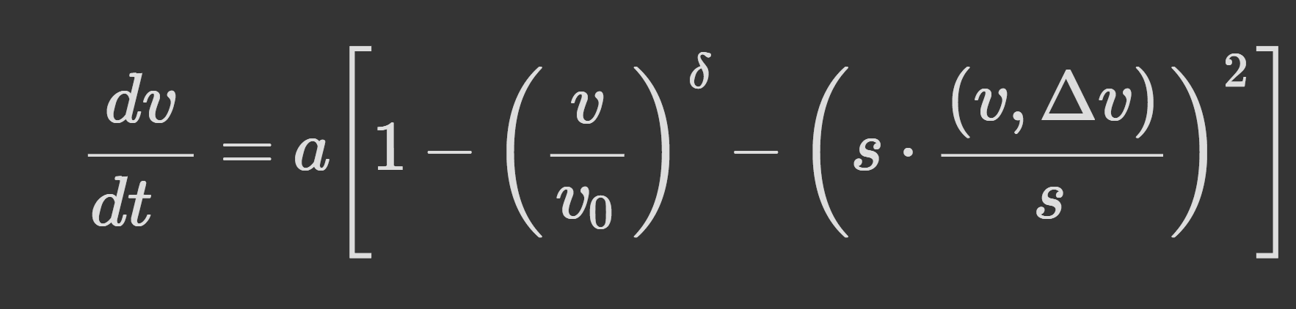
To simulate the different vehicle trajectories, we implemented the Intelligent Driver Model (IDM). This model was programmed as a Python function that calculates acceleration, based on the following provided equation.
As a group we utilized Euler's Method for numerical integration to update the vehicles speed and position at each 0.1s time interval. Then specially calibrated the Desired Time Headway(T) and Minimum Spacing(s0) to test how cautious or aggressive parameters affected the virtual follower's ability to match the real-world NGSIM data.

Results and Discussion:

As instructed, five different plots were created to help the understanding of transportation trends.

With the first Time-Series Plot, we analyzed the Speed of both the Follower and the Leader according to time. The follower typically follows the leader’s acceleration, but still includes some instances with lag. This could come from a slower processing time from the follower or sudden changes from the leader.

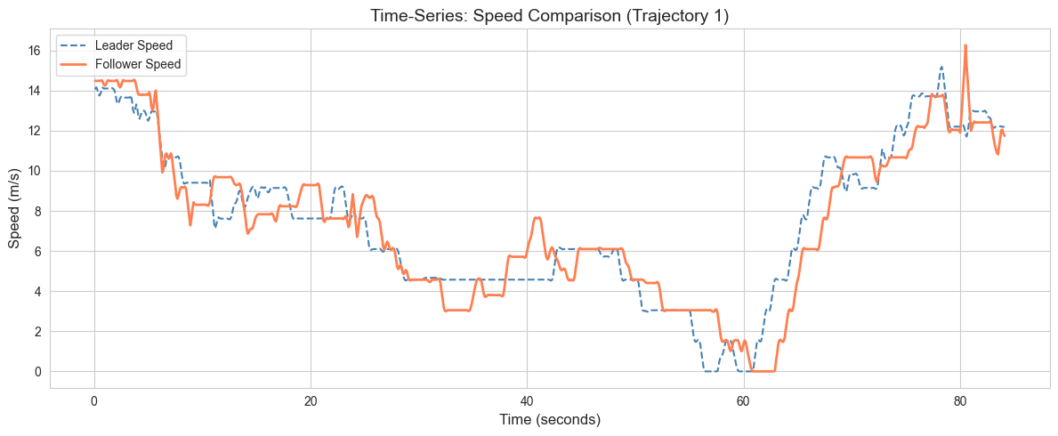

In the second time-series plot, it is shown that the Follower’s path is closely matched to the leader’s path. The acceleration fluctuates about zero, showing the acceleration about zero and possible braking below zero. High peaks of acceleration mostly indicated the Follower catching up to the leader and low valleys as the Follower attempting to maintain a safe distance from the Leader.
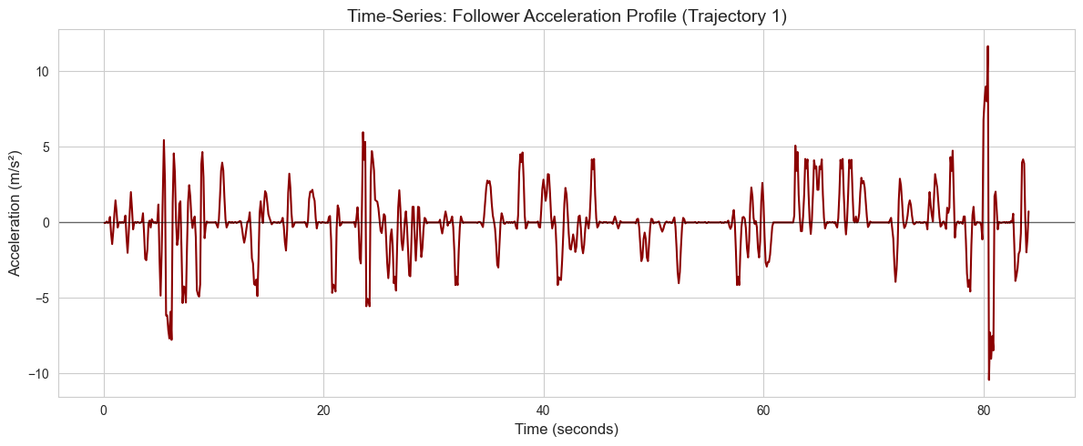

The Histogram shown below shows the frequency of the follower’s speed. The most frequent speeds fall in the middle, between 7.5 m/s to 12.5 m/s. These speeds represent the typical traffic flows. Higher and lower speeds do not happen as frequently These can indicate traffic conditions respectively.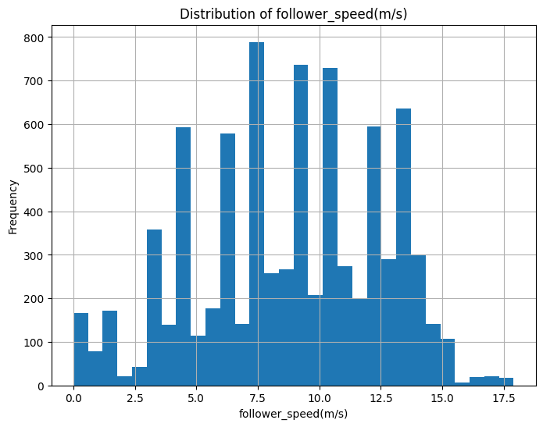

The Bar Chart created for the Average Trip Frequency by Household Income. The chart shows a positive correlation between average trips and household income. Higher-income households make more trips compared to lower-income households. This graph can help establish infrastructure planning and even with public transportation. (Urban Institute, 2020)
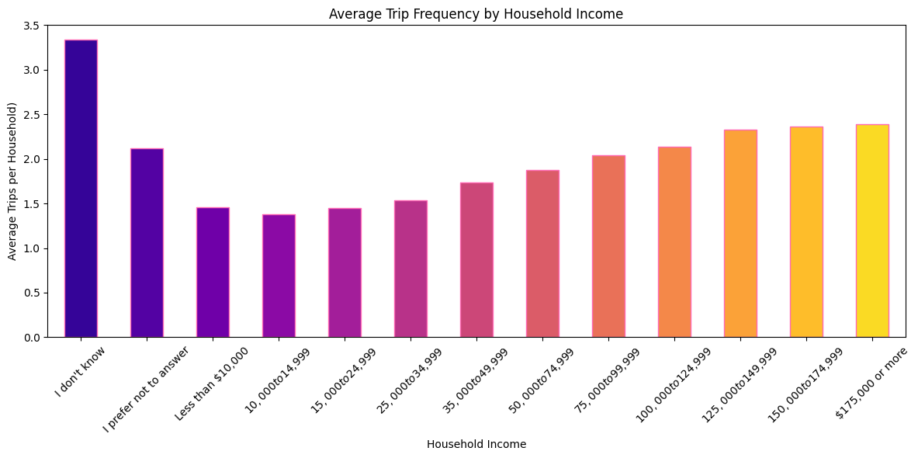
In theStudy Simulation below, it is shown that the Foller acceleration closely mirrors the leader acceleration. There is slight lag from possible sudden movements. The IDM does capture the general trend of the Follower's acceleration. However, The IDM captures a more smoother response as compared to the actual follower. The IDM is a good representation of the follower’s acceleration and can help model traffic behaviors.

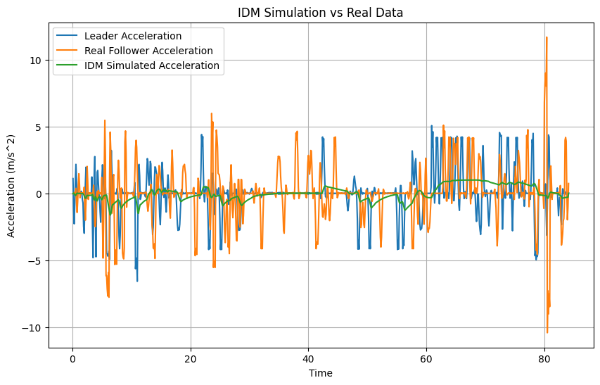

Sources:

Urban Institute. (2020, February 12). How commuters with low incomes use public transit — and how one city expanded ridership. Urban Wire. https://www.urban.org/urban-wire/how-commuters-low-incomes-use-public-transit-and-how-one-city-expanded-ridership

